**Newspaper of the Cabinet of Ministers of Ukraine**

**"Government Courier"**

**October 18, 2024**

[**https://ukurier.gov.ua/uk/news/povidomlennya-pro-zastosuvannya-poperednih-antidem/**](https://ukurier.gov.ua/uk/news/povidomlennya-pro-zastosuvannya-poperednih-antidem/)

**NOTIFICATION**

**on the application of preliminary anti-dumping measures**

**on the import into Ukraine of radiators for heating originating in**

**the Republic of Türkiye and the People’s Republic of China**

In accordance with the Law of Ukraine "On the Protection of the National Product Producer from Dumping Imports" (*hereinafter - the Law*) based on the complaint of the "SAN TECH RAY" LLC and the "YUTERM UKRAINE" LLC by the decision of the Interdepartmental Commission on International Trade (*hereinafter - the Commission*) dated April 12, 2024, No. AD-561/2024/441-01, an anti-dumping investigation was initiated regarding the import into Ukraine of heating radiators originating from the Republic of Türkiye and the People's Republic of China (*hereinafter referred to as the investigation*).

**According to the mentioned decision of the Commission, the object of the investigation was the product with the following description:**

radiators for heating (steel, aluminum, bimetallic), classified under the codes ex7322 19 00 00, ex7615 20 00 00, ex7616 99 10 00, ex7616 99 90 00 according to the Ukrainian classification of goods of foreign economic activity.

The mark “ex” next to the classification code means that the investigation is carried out in relation to the goods, the description of which is defined in the decision (*hereinafter - the Goods*).

**The countries of origin of the Goods:** the Republic of Türkiye and the People’s Republic of China.

The investigation of the facts regarding the presence of dumping imports was carried out within the investigation period immediately preceding the initiation of the investigation: 04/01/2023 - 03/31/2024 (hereinafter referred to as the investigation period).

The investigation of the facts regarding the existence of damage to the national producer, as well as the establishment of the fact of the existence of a cause-and-effect relationship between the dumping imports and the damage to the national producer, was carried out within the research period: 01.01.2021 - 03.31.2024 (hereinafter - the research period).

In accordance with the Law, the Commission reviewed the materials submitted by the Ministry of Economy of Ukraine on the progress of the investigation and, based on the results of their consideration, established:

"SAN TECH RAY" LLC and "UTERM UKRAINE" LLC is a proper national producer within the meaning of clause 16 of article 1 of the Law, since their share in the total production of goods in Ukraine is more than 50%;

The goods produced by the national producer, in the sense of the provisions of paragraph 26 of article 1 of the Law, are similar to the goods that are the object of the investigation;

a preliminary positive conclusion regarding the presence during the investigation period of dumping imports into Ukraine of goods originating from the Republic of Türkiye and the People's Republic of China. The calculation of the preliminary dumping margin was carried out on the basis of a comparison of the average sales prices of the Goods in the domestic markets of the Republic of Türkiye and the People's Republic of China (on terms of delivery EXW, excluding VAT) with the average prices of imports into Ukraine of the Goods originating from the Republic of Türkiye and the People's Republic of China, adjusted to the average costs of transporting the Goods from the ports of the Republic of Türkiye and the People's Republic of China to the border of Ukraine, as a percentage of the customs value of the Goods. A preliminary positive conclusion was made regarding the validity of the method, on the basis of which the preliminary dumping margin was determined at the level of 41,86% for producers and exporters of Goods originating from the Republic of Türkiye and at the level of 42% for producers and exporters of Goods originating from the People's Republic of China;

a preliminary positive conclusion on causing significant damage to the national producer. During the research period, there was a deterioration of a number of financial and economic indicators of the national goods producer: production volumes - by 74,56%, production capacities - by 13,75%, the level of utilization of production capacities - by 70.5%, volumes of sales of goods on the domestic market of Ukraine - by 40,97%, the profitability of the sale of the Goods on the domestic market of Ukraine – by 2095,19%, the financial result from the sale of the Goods on the domestic market of Ukraine – by 1606,24%, the number of employees employed in the production of similar Goods – by 37,22% , labor productivity - by 59,47%, and the volume of investments in dollar terms - by 78,69%. At the same time, there are facts that indicate the possibility of causing significant damage to the national producer already during the investigation, namely the increase in the volume of imports of goods originating from the Republic of Türkiye and the People's Republic of China in the 1st quarter. 2024 compared to the first quarter 2023 by 157,13%, compared to the first quarter 2021 – by 21,19% under the conditions of downward dynamics of average prices of such imports. Considering the presence of significant export potential of the Republic of Türkiye and the People's Republic of China, the situation that has developed requires taking urgent measures to prevent damage to the national producer at the stage of the investigation;

a preliminary positive conclusion regarding the presence of a cause-and-effect relationship between the dumping import into Ukraine of goods originating from the Republic of Türkiye and the People's Republic of China and causing significant damage to the national producer, which is confirmed by the following:

- the volume of imports into Ukraine of goods originating from the Republic of Türkiye and the People's Republic of China during the research period increased by 31,27% relative to the consumption of similar goods in Ukraine, relative to production by 173,29%;

- dumping imports into Ukraine of goods originating from the Republic of Türkiye and the People's Republic of China were carried out under such conditions that prevented a significant increase in prices for similar goods of the national producer, which would have taken place in the absence of dumping imports;

- during the research period, there was an influence of other factors related to military operations on the territory of Ukraine and export activities of the national producer. At the same time, the influence of such factors does not exclude the previously established fact regarding the presence of a cause-and-effect relationship between dumped imports and causing significant damage to the national producer;

the national interests of Ukraine require the application of preliminary anti-dumping measures in order to prevent damage to the national producer.

Taking into account the above and guided by the provisions of Article 14 of the Law, the Commission adopted a decision dated 15.10.2024 No. AD-568/2024/441-01 "On the application of preliminary anti-dumping measures on the import into Ukraine of radiators for heating originating from the Republic of Türkiye and the People's Republic of China" , according to which it applied preliminary anti-dumping measures on the import into Ukraine of goods originating from the Republic of Türkiye and the People's Republic of China, which has the following description:

heating radiators (steel, aluminum, bimetallic) (excluding towel warmers, water-based underfloor convectors and designer radiators (vertical and horizontal tubular) classified under codes ex 7322 19 00 00, ex 7616 99 10 00, ex 7616 99 90 00 according to the Ukrainian classification of goods of foreign economic activity.

The mark "ex" next to the classification code means that anti-dumping measures are applied to the goods described in the decision.

**Approximate typical appearance of aluminum and bimetallic radiators**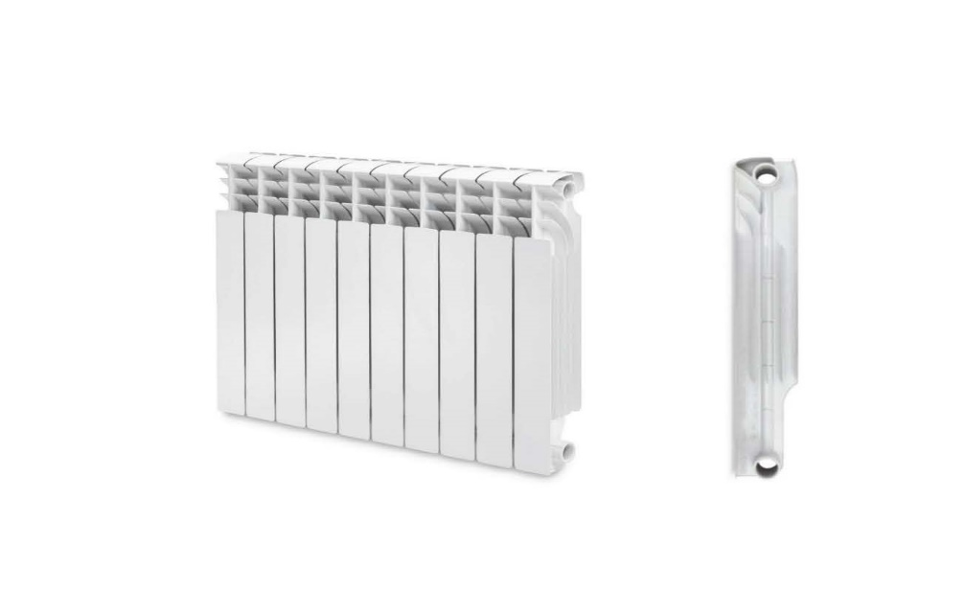

**Approximate typical appearance of steel radiators** 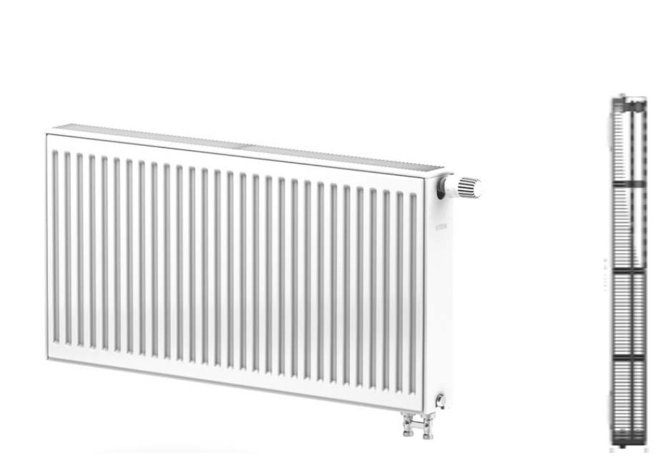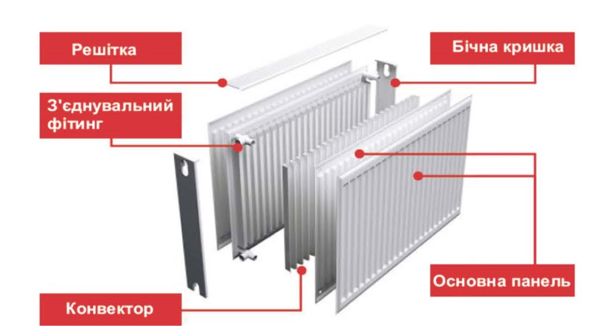

Preliminary anti-dumping measures are applied for a period of four months by introducing the payment of preliminary anti-dumping duties at the following rates:

**for producers and exporters of goods originating from the Republic of Türkiye – 41,86%;**

**for producers and exporters of goods originating from the People's Republic of China - 42%.**

Preliminary anti-dumping duty is paid as a percentage of the customs value of the goods.

The payment of the preliminary anti-dumping duty is carried out in cash or non-cash form, or by depositing the amount of the duty on a deposit, or issuing a corresponding debt obligation, unless otherwise provided by the legislation of Ukraine.

The preliminary anti-dumping duty is handled by the customs authorities of Ukraine regardless of the payment of other taxes and fees (mandatory payments).

The application of previous anti-dumping measures should not create obstacles to customs clearance of goods.

Import into the customs territory of Ukraine of goods that are subject to the application of previous anti-dumping measures, without a certificate of origin or other documents on the origin of the goods, defined by international agreements on free trade, consent to the binding of which has been granted by the Verkhovna Rada of Ukraine, and in case of impossibility determination of its origin is carried out with the payment of the previous anti-dumping duty at the highest rate.

The decision of the Commission dated October 15, 2024 No. AD-568/2024/441-01 shall enter into force **5 days** after the publication of this notice.

**Interdepartmental Commission on International Trade**